Local Rag

Pull llama 3.2

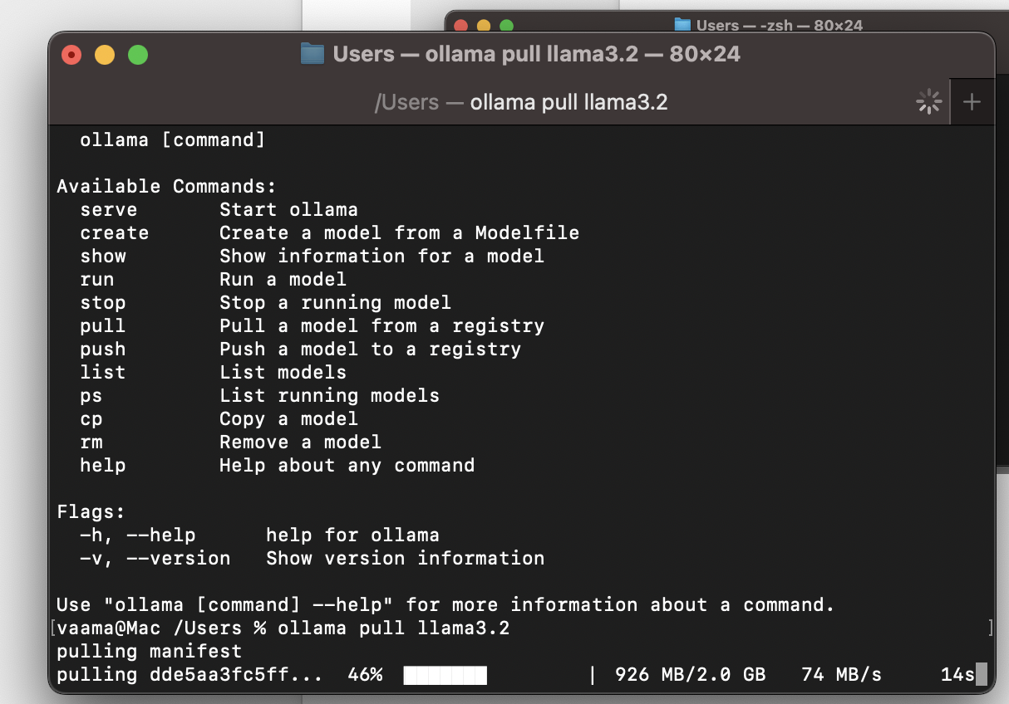

ollama pull mxbai-embed-large

